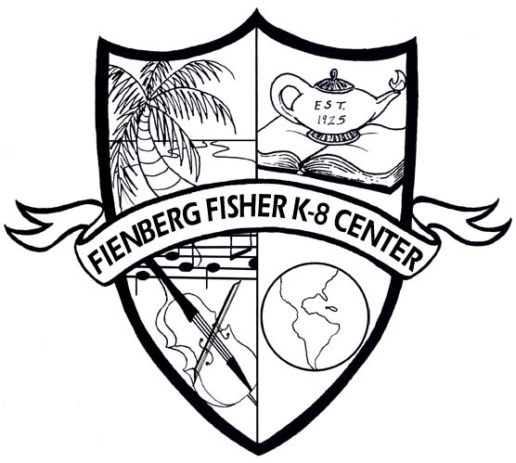

Fienberg-Fisher K-8 Center
IB World School
PYP Assessment Policy

Rationale

Assessment is a tool that drives instruction. At Fienberg-Fisher K-8 Center we believe that during the years of Pre-K to 5th grade the use of various forms of assessment strengthens teaching and guides instruction thus improving the learning process. Assessment is integral to all teaching and learning. It is also central to the International Baccalaureate Primary Years Programme’s goal of thoughtfully and effectively guiding students through the five essential elements of learning: the understanding of concepts, the acquisition of knowledge, the mastering of skills, the development of attitudes, and the decision to take responsible action.

Purpose

Assessment is an essential part of the instructional cycle. It provides information about student learning and development, as well as a framework for planning, self-reflection, and collaboration.

Promotion of Learning

Assessing prior knowledge and experience

Differentiating instruction to meet individual need

Engaging learners in reflection to determine strengths and weaknesses and to set

goals

Providing feedback for students

Expanding student learning opportunities

Reporting of Student Learning

Examples of student work or performances

Data Chats

Report Cards/ Progress Reports

Observations

Collaborative Conversations/ Common Planning

Programme evaluation uses a variety of student assessments to:

Assess the levels of students’ current knowledge and experience before

embarking on new learning

Guide teacher planning and presentation

Assess student performance relative to national, state, and local standards as well as PYP expectations

Focus on closing the achievement gaps among students

Inform all stakeholders

Assessment Types

Formative Assessment is a self-reflective process that intends to promote student attainment and is the bidirectional process between teacher and student to enhance, recognize and respond to the learning. Formative assessments are connected to instruction and learning that provides instant and frequent feedback during the learning process. This form of assessment looks like: anecdotal records, peer to peer evaluations, student reflections, student/teacher feedback, and/or classroom participation by students. This type of assessment can be used to evaluate various aspects of the learning process, including inquiry but also the learner profile and student growth.

Summative Assessment is given to determine that the student understands the central idea of the unit of inquiry. Many associate summative assessments only with standardized tests such as state assessments, but they are also used at and are an important part of district and classroom programs. Summative assessment at the district/classroom level is an accountability measure that is generally used as part of the grading process. Some examples of summative assessments are state assessments, district benchmark or interim assessments, end-of-unit or chapter tests, end-of-term or semester exams, and/or scores that are used for accountability for schools (Annual Yearly Progress) and students (report card/progress report grades).

Effective Assessments:

Effective assessment should:

Provide feedback for students and teachers to revise/advance performance,

learning, and teaching

Be formative, summative and demonstrate what students know,

understand, and are able to apply

Use reflection as an essential and integral part of self, peer, teacher, and

parent assessment

Utilize learning style, cultural, gender, linguistic, and racial differences

Be anchored in authentic tasks

Provide evidence of progress along a continuum of criteria that are clearly

known and understood in advance

Strategies:

Observations: All students are observed regularly with a focus on the individual,

the group, and/or the whole class.

Performance Assessments: Students are presented with a task that represents the

kind of challenges that adults face in the world beyond the classroom. It requires using a repertoire of knowledge and skills to accomplish a goal or solve an open-ended problem.

In addition, it entails the thoughtful application of knowledge rather than recalling

facts. It has an identified purpose or audience, involves a realistic scenario, it has an established criteria and requires developing an authentic product or performance.

Transdisciplinary Skills Assessments (research, thinking, communication, self-

management and social skills): The focus is on the process and skill application rather than on the product. These skills are regularly observed in real contexts using checklists, narrative notes, and inventories.

Open-Ended Assessments: Students are presented with a challenge and asked to

provide an original response.

Tests/Quizzes: These single-occasion assessments provide a snapshot of students’

specific knowledge.

Tools:

Rubrics: Rubrics are established sets of criteria used for scoring or rating

students’ tests, portfolios or performances. The descriptors tell the students and the assessor what characteristics or signs to look for in the work and then how to rate that work on a predetermined scale. Rubrics can be developed by students as well as by teachers.

Benchmarks/ exemplars: These are samples of students’ work that serve as

concrete standards against which other samples are judged. Benchmark/exemplars can be used in conjunction with rubrics. Benchmarks should be appropriate and useable within a particular school context.

Portfolios: An ongoing, purposeful collection is composed of selected student

work and is designed to demonstrate growth, creativity, and reflection. Continuity Portfolios and Grade Level Portfolios are in use throughout the school. Continuity Portfolios are assembled, retained, and passed on to the students’ teachers each school year for both the benefit of the students and the teachers. Grade Level Portfolios are assembled during the school year for the purpose of that school year only.

Checklists: These are lists of information, data, attributes, or elements that should

be present.

Anecdotal records: Anecdotal records are brief, written notes based on

observations of students. These records need to be systematically compiled and organized.

Classroom Observations: Observations of students’ work performance

individually or as a whole by the teacher.

Reporting:

Reporting is how the school shares students’ assessment results, achievement,

grades, effort, and progress to parents throughout the school year; primarily through progress and report cards. This is done so to:

Involve parents, students, and teachers as partners

Reflect what the school community values

Be comprehensive, honest, fair, and credible

Be clear and understandable to all parties

Allow teachers to incorporate what they learn during the reporting process

into their future teaching and assessment practice

Conferences:

Parent/Teacher Conferences

Parent/Teacher conferences take place throughout the year and serve

different purposes. Parents or teachers may initiate a parent conference.

Student-Led Conferences

Parents will be invited to discuss and view student portfolios once a year.

This will take place after the second marking period. Students will share their portfolios and discuss the unit planners they have completed. Students will also share their Learner Profile Progress Report. During these converses students will be able to speak to parents and explain where they are as individuals in the IB PYP.

Teacher/Student Conferences

When teachers and students in engage in this type of conference they

discuss their progress as a learner. Teachers use these moments to discuss progress in various subject areas as well as in the social emotional areas of development.

Parent/Teacher/Student Conferences

Our prekindergarten program opts to meet with parents, students alongside

the teacher because of the age of the students. During these conferences, teachers and student present to the parent. They discuss learning as it relates to all areas of development within and outside of the IB PYP. Parents reflect on learning, view work and are able to discuss student progress.

Student Portfolios:

Organization

Pieces of work included in the portfolio should be linked to unit planners.

The work can be created during a unit planner or may be an extension of a unit planner.

Students will select pieces of work from portfolio. Teachers and

Specialists may also recommend certain pieces of work for portfolio.

For every piece of work that correlates to a unit planner a reflection

component will be included for 3rd – 5th grade. For PK – 2nd, reflections may be dictated by students, contain teacher notes or may be written student reflections.

If a summative assessment is included in the portfolio, the accompanying

rubric or checklist will be attached.

The yearly Learner Progress Report will be included in the portfolio.

Portfolios will be utilized during student-led conferences.

Teachers, parents, students and instructional leaders will have access to

portfolios.

Portfolios will be readily available in the classroom and will be labeled

with student names.

Binders will serve as portfolios. They will be tabbed by grade level and

will contain student work in sheet protectors.

Portfolios will be swapped at the beginning of every school year among

teachers using class lists.

The portfolio ultimately belongs to the student. If the student leaves the

school, the student will take the portfolio with him/her. If a student moves from one class to another, the portfolio will move with the student.

Accessibility:

Student portfolios will be available to teachers, staff members, authorized

school personnel, and parents. However, formative assessments will only be accessible to the student, teacher, parent, any staff member, or administration that works with that student. These records are otherwise confidential and not to be shared.

